# Backup Policy

The backup policy we should use is the differential backup. We should use this backup method because this method only makes a backup of the files that were changed. This is good for us because some of our table data might not change that much and doing full backups every time changes get made would take a significant amount of time to do, whereas if we just back up the files that changed like new patient or existing patient getting vaccinated this would lower the amount of time that is spent on backing up the database.

# Implementation



First we have to create a logical backup device for a selected disk file.

Before we can start creating differential backups we have to ensure that our database has been fully backed up at least once.

This is the code that gets run after an elapsed (Recommend doing it at the end of a day) time and will only backup files that have been changed.

Make backups of the transaction logs.

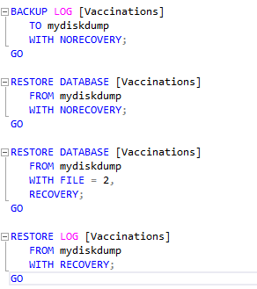

The when needed we can run the following code to restore the database or restore the differential database, and also restore the transaction logs